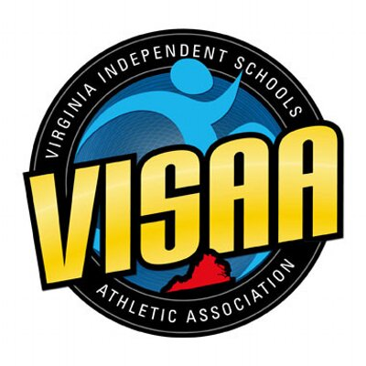
39th Girls Basketball State Tournament

Athletic Directors and Girls Basketball Coaches:
I hope the fall season has been enjoyable and rewarding for you and your school community. As everyone is gearing up for the beginning of another basketball season, I wanted to touch base with you to provide some details regarding this year’s basketball state tournament.
I am pleased to inform you that VISAA will bring the boys and girls basketball championship games together on Saturday, March 2, 2024, at two sites in Richmond. The Division I & IV semi-finals and finals will be at Benedictine College Preparatory and the Division II & III semi-finals and finals will be at The Steward School.

Below are the tentative dates for the 2023-2024 VISAA Girls Basketball State Tournament. Please mark all four dates on your calendar.

First Round Tuesday, February 27th at higher seed (5-12)
Quarter-Finals Wednesday, February 28th at higher seed
Semi-Finals Friday, March 1st at Sites Below
Time | Benedictine | Steward
2:00pm | Girls DIV | Girls DII
3:45pm | Girls DIV | Girls DII
5:30pm | Girls DI | Girls DIII
7:15pm | Girls DI | Girls DIII

Finals Saturday, March 2nd at Sites Below
Division IV – 12:00 pm at Benedictine College Preparatory
Division I – 2:00 pm at Benedictine College Preparatory
Division II – 4:00 pm at The Steward School
Division III - 6:00 pm at The Steward School

A reminder, only member schools of the VISAA are eligible to participate in the state tournament. Membership dues and all required school information must be submitted to VISAA in order for a school to be eligible for participation. If you have any questions concerning your school eligibility, contact Adam Brick at: abrick@visaa.org.

Divisions for this year’s tournament are based on the enrollment numbers provided by member schools in September 2021 to VISAA. This year, the girls basketball tournament will still have four divisions, with each division competing for a championship. We will continue to select 12 teams from each division to participate in the tournament. Division breakdowns are already posted on the VISAA website and you should look there if you need to know who is in what division.

We will continue to use the 30 second shot clock for all rounds of the Division I Tournament, ONLY. We will use the 30 second shot clock rules we used last year, which are posted on the VISAA website under Girls Basketball.

Please be sure to send your rosters, game schedule, and results to AP Prep Scores and post on MaxPreps as soon as possible.

Finally, listed below are VISAA financial policies pertaining to hosting VISAA championship events.
- Host school will be responsible for absorbing all expenses involved in hosting first round and quarterfinal games of VISAA championship events.
- Host school must charge admission to the event and send the income with financial form within fourteen days of the event. Admission Charge for first round and quarterfinal games is $5.00.
- There will be a $50 penalty for monies and forms not received within fourteen days.
- There will be a $100 penalty for monies and forms not received within thirty days.
- Failure to charge admission at events or not returning financials forms within deadlines may result in a school not hosting in that sport for the following school year.
- Forms can be found on the VISAA Website under “Members Only” and then “Forms”.

Don’t hesitate to contact me or any member of the committee if you have questions. You can contact me at: kara.bacile@stewardschool.org or 804-441-5869.

Sincerely,

Kara Bacile

VISAA Girls Basketball State Committee:
Kara Bacile, Chair – The Steward School
Scott Allen, Officer – St. Paul VI Catholic High School
Jody Patrick, Advisor – Flint Hill School
Kim Aston, Advisor – Nansemond-Suffolk Academy
Phil Stinnie – St. Anne’s-Belfield School
Cameron Battle – The New Community School
James Braxton – The Miller School of Albemarle
Rives Fleming – Collegiate School
Tammy Holder – Veritas School
Frank Kahrs – Grace Christian School (Staunton)
Emily Mauk – Walsingham Academy
Larry Starr – The Blessed Sacrament Huguenot
Stuart Baiza – Nansemond-Suffolk Academy
Sedrick Winston – Flint Hill School
Becky Barvick – Chelsea Academy
Zach Coyle – Banner Christian School

